YEAR 6 AUTUMN 24-25
Term 3 |  | Term 4
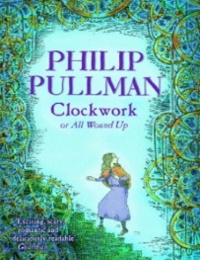 |  | 
Outcome 1- Setting/Character Description(10 days) | Outcome 1- Persuasive Text(10 days) | Outcome 1-Narrative  (10 days) | Outcome 3- Survival Guide  (10 days)
STAR WORDS: Bell Tower, Tavern, Mechanical, Apprentice, Burgomaster, Doctor, Prince, Sleigh, Royalty,  GRAMMAR: -LI: To know how to use fronted adverbials for time, manner and place  GRAMMAR IN CONTEXT: - LI: To use fronted adverbials in the context of the text | STAR WORDS: Dark Sky Park, Reserve, Constellation, Aurora Borealis, Light Pollution, Environment, Conservation  GRAMMAR: -LI: To know how to use verb tenses consistently in my writing (Present)  GRAMMAR IN CONTEXT: - LI: To use the present tense in the context of the text | STAR WORDS: Tribe, Camp, Trial by combat, Demon, Possessed, Mountain of the World Spirit, Bright beast that bites hot, Fast wet, Claw that flies, Pelt, Tall-Tailless, Female Tailless, Mage, Light and Dark, Moons, Summers  GRAMMAR: -LI: To know how to use inverted commas  GRAMMAR IN CONTEXT: - LI: To use contracted forms in dialogue in the context of the text | STAR WORDS: World, Environment, Tool, Cut, Danger, Pelt, Jerkin, Hide, Quiver, Bow, Blade, Knife, Shelter, Fever  GRAMMAR: -LI: To know how to use coordinating and subordinating conjunctions  GRAMMAR IN CONTEXT: - LI: To use conjunctions in the context of the text
Outcome 2- Explanation Text (10 days) | Outcome 2- N/A | Outcome 2- Balanced Argument  (10 days) | Outcome 4- Instructions (How to make a Demon Bear)  (10 days)
STAR WORDS: Mechanism, Cog, Gear, Lever, Armour, Sensors, Rust, Spring, Wind, Joint, Hinge, Sword, Activate, Flower of Lapland  GRAMMAR: -LI: To know how to use prepositional phrases for clarity  GRAMMAR IN CONTEXT: - LI: To use prepositional phrases in the context of the text |  | STAR WORDS: Companion, Guide, Prophecy, Promise, Destiny, Mountain of the World spirit, Guilt, Responsibility  GRAMMAR: -LI: To know how to use modal verbs  GRAMMAR IN CONTEXT: - LI: To use modal verbs in the context of the text | STAR WORDS: Spirit, Demon, Possessed, Evil, The Red Moon, Mage, Bear  GRAMMAR: -LI: To know how to use commas in a list  GRAMMAR IN CONTEXT: - LI: To use colons in the context of the text

YEAR 6 - SPRING 24-25
Term 1 | Term 2
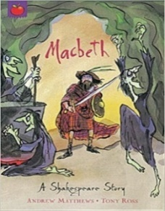 |  | 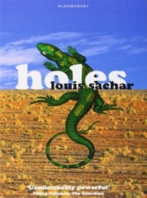
Outcome 1- Soliloquy (10 days) | Outcome 1- Biography of Shakespeare  (10 days) | Outcome 1- Formal Letter  (10 days)
STAR WORDS: Ambition, Guilty, Murder, Betrayal, Assassination, Royalty, Heir, Descendant, Dunsinane, Hag, Bewitched  GRAMMAR: LI: To know how to use 1st and 3rd person pronouns  GRAMMAR IN CONTEXT: - LI: To use pronouns in the context of the text | STAR WORDS: William Shakespeare, Globe Theatre, Playwright, Stratford-upon-Avon, Comedy, Tragedy, Sonnet, Biography, Hamlet  GRAMMAR: -LI: To know how to use coordinating and subordinating conjunctions  GRAMMAR IN CONTEXT: - LI: To use conjunctions effectively in the context of the text | STAR WORDS: Juvenile, Detention centre, Crime, Punishment, Venomous, Abuse, Racism, Desolate, Arid, Outlaw, Canteen  GRAMMAR: -LI: To know how to use relative clauses to add additional information  GRAMMAR IN CONTEXT: - LI: To know how to use punctuation for parenthesis in the context of the text
Outcome 2-Retelling (10 days) | Outcome 2- N/A  (5 days) | Outcome 2- Diary Entry  (10 days)
STAR WORDS: Birnham Wood, Premonition, Trickery, Revenge, Army, Battle, Cavalry, Consequence, Just desserts  GRAMMAR: -LI: To know how to use inverted commas  GRAMMAR IN CONTEXT: - LI: To use inverted commas for direct speech in the context of the text |  | STAR WORDS: Thirst, Hunger, Blisters, Labour, Sweltering, Welfare, Character building, Curse, Desert, Texas, Canteen  GRAMMAR: -LI: To know how to use question marks  GRAMMAR IN CONTEXT: - LI: To know how to use rhetorical questions in the context of the text
Outcome 3- N/A | Outcome 3- N/A | Outcome 3- Newspaper Article  (10 days)

YEAR 6- SUMMER 24-25
Term 5 |  | Term 6
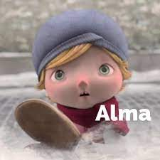  Film Clip- The Literacy Shed |   Film Clip- The Literacy Shed | 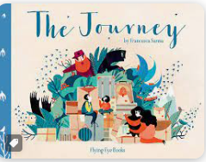
Outcome 1- Narrative (Retelling)  (10 days) | Outcome 1- Autobiography  (10 days) | Outcome 1- Diary  (5 days) | Outcome 4- Poetry  (5 days)
STAR WORDS: Graffiti, Gillet, Mitten, Possessed, Trapped, Coagulated, Child-catcher, Doll, Peculiar, Foreshadow, Gaping mouth  GRAMMAR IN CONTEXT: -LI: To know how to use colons in the context of the text  GRAMMAR IN CONTEXT: - LI: To use semi-colons in the context of the text | STAR WORDS: Soldier, Reminisce, Hobby-horse, Comrade, War, Wife, Grandchild, Medic, Wedding Band, Gift, Piano, Keys, Melody, Tune, Dream  GRAMMAR: -LI: To know how to use relative clauses  GRAMMAR IN CONTEXT: - LI: To use relative clauses in the context of the text | STAR WORDS: Family, Refugee, Chaos, Father, Mountains, Strange, Frightened, Displaced, Border, Guard, Mother, Money, Migrant, Immigrant, Asylum Seeker, Journey, Capsize, Shore, Migrate  GRAMMAR: -LI: To know how to use the active and passive voice  GRAMMAR IN CONTEXT: - LI: To use the active or passive in the context of the text | STAR WORDS: Movement, Displaced, Homeless, Alone, Solitary, Forced, Migration, Separation, Escape, Adventure, Dilemma, Protect, Culture, Safety  GRAMMAR: -LI: To know how to use hyphens  GRAMMAR IN CONTEXT: - LI: To use hyphens in the context of the text
Outcome 2- N/A | Outcome 2- N/A | Outcome 2- Newspaper Clip  (5 days) | Outcome 5- N/A
STAR WORDS: Refugee, Family, Border, Separated, Immigrant, Capsize, Channel, Crossing, Shore
GRAMMAR: -LI: To know how to use inverted commas (direct and reported speech)
GRAMMAR IN CONTEXT: - LI: To have conscious control over formality in the context of the text
Outcome 3- N/A | Outcome 3- N/A | Outcome 3- Argument (Pro-supporting refugees)  (5 days) | Outcome 6- N/A
STAR WORDS: Compassion, Refugee, Support, Accommodate, War, Famine, Dictatorship, Kindness, Understanding, Charity, Generosity, Refugee Camps
GRAMMAR: -LI: To know how to use causal conjunctions
GRAMMAR IN CONTEXT: - LI: To use causal conjunctions in the context of the text

