YEAR 4- AUTUMN 24-25
Term 1 |  | Term 2
 | 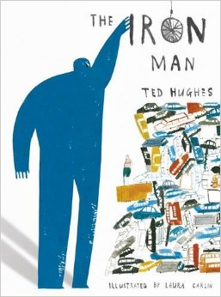 | 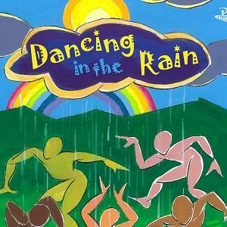 | 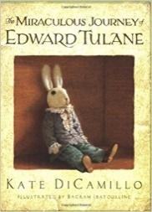
Outcome 1- Narrative (Next Chapter) (10 days) | Outcome 1- Diary  (10 days) | Outcome 1- Poetry (Carnival Jumbie) (10 days) | Outcome 1- Letter  (10 days)
STAR WORDS cake, Grandma, poorly, forest, children, terrified  GRAMMAR: -LI: To use fronted adverbials  GRAMMAR IN CONTEXT: - LI: To use fronted adverbials in context of the story | STAR WORDS: Iron man, enormous, frightened, Hogarth, guilty, machinery  GRAMMAR: LI: To use subordinating conjunctions  GRAMMAR IN CONTEXT: - LI: To use subordinating conjunctions in context of Iron Man | STAR WORDS: Jumbie, calypso, steelban, ole mas,  GRAMMAR: LI: To use similes, metaphors and alliteration  GRAMMAR IN CONTEXT: - LI: To use similes, metaphors and alliteration in context | STAR WORDS Abilene, adventure, journey, petrified, alone  GRAMMAR: -LI: To use simple, compound and complex sentences  GRAMMAR IN CONTEXT: - LI: To use complex, compound and complex sentences in a letter.
Outcome 2- N/A | Outcome 2- Newspaper Article  (10 days) | Outcome 2- N/A | Outcome 2- Narrative (Next Chapter)  (10 days)
 | STAR WORDS defeat, Australia, victory, challenge, monster  GRAMMAR: -LI: To use inverted commas  GRAMMAR IN CONTEXT: - LI: To use inverted commas for newspaper quotes |  | STAR WORDS Abilene, adventure, journey, petrified, alone, Maggie  GRAMMAR: -LI: To use expanded noun phrases  GRAMMAR IN CONTEXT: - LI: To use expanded noun phrases to describe

YEAR 4 SPRING 24-25
Term 3 | Term 4
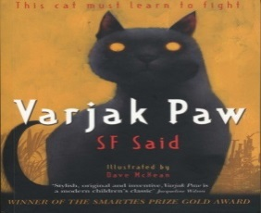 | 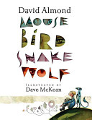
Outcome 1- Diary Entry (10 days) | Outcome 1- Character Description (10 days)
STAR WORDS mercy, Elder Paw, sinister, cunning, Mesopotamian  GRAMMAR: -LI: To use co-ordinating conjunctions  GRAMMAR IN CONTEXT: - LI: To use co-ordinating conjunctions in a diary | STAR WORDS mouse, bird, snake, wolf  GRAMMAR: -LI: To use expanded noun phrases  GRAMMAR IN CONTEXT: - LI: To use expanded noun phrases to describe
Outcome 2- Newspaper Article (10 days) | Outcome 2- Graphic Novel (10 days)
STAR WORDS The Vanishings, defenceless, innocent,  GRAMMAR: -LI: To use inverted commas  GRAMMAR IN CONTEXT: - LI: To use inverted commas for newspaper quotes | STAR WORDS  GRAMMAR: -LI: To  GRAMMAR IN CONTEXT: - LI: To
Outcome 3- Narrative (Chapter from a different perspective) (10 days) | Outcome 3- N/A
STAR WORDS gentleman, attack, vicious, lurched
GRAMMAR: -LI: To use contractions
GRAMMAR IN CONTEXT: - LI: To use contraction to write sentences about Varjak Paw

YEAR 4- SUMMER 24-25
Term 5 |  | Term 6
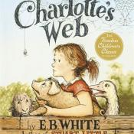 | 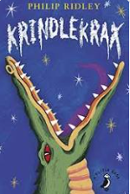 | 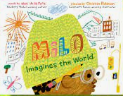
Outcome 1- Letter  (10 days) | Outcome 1- Comparative Write  (10 days) | Outcome 1- Narrative (Retelling)  (5 days)
STAR WORDS concerned, Arable, orchard, Mr, Mrs, Zuckerman, Your Sincerely, Wilbur, Fern  GRAMMAR: -LI: To use commas in a list  GRAMMAR IN CONTEXT: - LI: To use commas in a list in a letter | STAR WORDS whereas, Elvis Cave, however, Lizard Street, similarly, equally, Krindlekrax, Corky, Ruskin Splinter  GRAMMAR: -LI: To use comparative conjunctions  GRAMMAR IN CONTEXT: - LI: To use comparative conjunctions to compare | STAR WORDS Milo, train, appearances, stereotype, judgement  GRAMMAR: -LI: To use inverted commas  GRAMMAR IN CONTEXT: - LI: To use inverted commas to retell the story
Outcome 2- Fact File (Spiders) (10 days) | Outcome 2- Descriptive Write | Outcome 2- Persuasive Writing  (5 days)
STAR WORDS tarsus, trochanter, femur, patella, tibia, spider, coxa, poisonous, Goliath-bird-eating-spider, metatarsus  GRAMMAR: -LI: To use adverbs  GRAMMAR IN CONTEXT: - LI: To use adverbs in a fact file | STAR WORDS enormous, spiky, bumpy, scaly, towering  GRAMMAR: -LI: To use pronouns  GRAMMAR IN CONTEXT: - LI: To use pronouns in context
Outcome 3- N/A  (10 days) | Outcome 3- N/A | Outcome 3- Non-Chronological Report  (10 days)

