YEAR 2- AUTUMN 24-25
Term 1 |  | Term 2
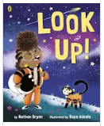 | 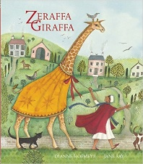 | 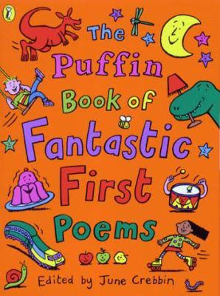 | 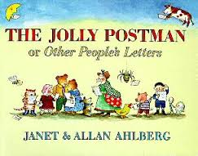 | 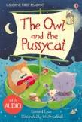
Outcome 1- Flyer  (10 days) | Outcome 1- Writing in Role  (5 days) | Outcome 1- Poetry (5 days)  Busy Day | Outcome 1- Letter  (5 days) | Outcome 1 - Postcard  (5 days)
STAR WORDS  Telescope, astronaut, orbit, flyer, gravity, phoenix, meteor shower  GRAMMAR: -LI: To identify and know how to use nouns  GRAMMAR IN CONTEXT: - LI: To identify and know how to use nouns in the context of the text | STAR WORDS:  Plains, Egypt, sphinx, pyramids, consult, taffeta, mistral, acacia,  GRAMMAR: -LI: To use expanded noun phrases  GRAMMAR IN CONTEXT: - LI: To use expanded noun phrases in the context of the text | STAR WORDS:  Verse, line, rhythm, beat,  GRAMMAR: -LI: To understand the vocabulary of poetry  GRAMMAR IN CONTEXT: - LI: To apply the vocabulary of poetry to poems | STAR WORDS  Porridge, harp, harassment, conjuror, rejuvenating, Hobgoblin, covens, cackle, travellers cheques, frock  GRAMMAR: -LI: To know the four sentence types  GRAMMAR IN CONTEXT: - LI: To use the four sentence types in the context of the text | STAR WORDS  Fowl, tarried, shilling, quince, runcible, bong trees  GRAMMAR: -LI: To know how to use tenses  GRAMMAR IN CONTEXT: - LI: To know how to use tenses in the context of the text
Outcome 2- Narrative (Writing in Role) (5 days) | Outcome 2- Letter to Egyptian King  (5 days) | Outcome 2 – Poetry  Sound Hunt | Outcome 2- Instructions  (5 days) | Outcome 2 – Innovated story  (5 days)
STAR WORDS  Comet, atmosphere, jet pack, binoculars  GRAMMAR: -LI: To use capital letters and full stops  GRAMMAR IN CONTEXT: - LI: To use capital letters and full stops in the context of the text | STAR WORDS  Great Pasha, amulet, felucca, pivoted, balmy, haboob, porcupine, pomegranates  GRAMMAR: LI: To use adverbs  GRAMMAR IN CONTEXT: - LI: To use adverbs in the context of the text | STAR WORDS  Wrinkle, splinter, shore, swell, roar  GRAMMAR: LI: To understand onomatopoeia  GRAMMAR IN CONTEXT: - LI: To use onomatopoeia in the context of a poem | STAR WORDS  Court, judge  GRAMMAR: -LI: To know how to use conjunctions  GRAMMAR IN CONTEXT: - LI: To know how to use conjunctions in the context of the text | STAR WORDS  Fowl, tarried, shilling, quince, runcible, bong trees  GRAMMAR: -LI: To know how to use expanded noun phrases  GRAMMAR IN CONTEXT: -LI: To use expanded noun phrases in the context of the text
 | Outcome 3- Narrative writing in role  (5 days) | Outcome 3 – Poetry  Fireworks
 | STAR WORDS  soiree, rotunda  GRAMMAR: -LI: To use adverbs of time  GRAMMAR IN CONTEXT: - LI: To use adverbs of time in the context of the text | STAR WORDS  Dazzle, sizzle, whizz, fizz, sparkle  GRAMMAR: -LI: To understand onomatopoeia  GRAMMAR IN CONTEXT: - LI: To use onomatopoeia in the context of a poem

YEAR 2 SPRING 24-25
Term 3 |  | Term 4
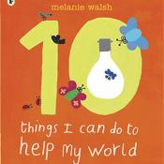 | 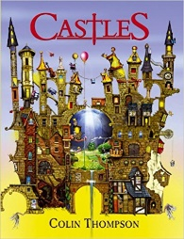 |  | 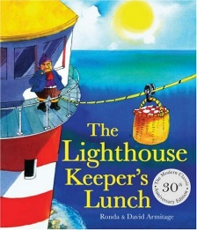
Outcome 1-Information Leaflet  (10 days) | Outcome 1- Information Text (10 days) | Outcome 1- Narrative (Sequel) (15 days) | Outcome 1- Narrative (Sequel)  (10 days)
STAR WORDS  Valuable energy, appliances, stand by, pollution  GRAMMAR: -LI: To know how to write questions  GRAMMAR IN CONTEXT: - LI: To know how to use commas in a list in the context of the text | STAR WORDS  Patagonia, Ark, bacteria, hibernate, mammoth, fossils, fortifications, portcullis, turrets  GRAMMAR: -LI: To know how to use conjunctions  GRAMMAR IN CONTEXT: - LI: To know how to use conjunctions in the context of the text | STAR WORDS  Traction, rejoice, lumber, fluorescent, suffocate, shrubbery, camouflage, Intergalactic, suspended animation, romper suit, bonnet, expanse  GRAMMAR: -LI: To know how to use adjectives to describe  GRAMMAR IN CONTEXT: - LI: To know how to use adjectives to describe in the context of the text | STAR WORDS  Industrious, concocting, appetising, garni, scavenging, varmints, scrumptious, devoured, brazen, accomplished, consolingly, ingenious, lackaday, sea shanties, leisurely  GRAMMAR: -LI: To know how to use capital letters and full stops  GRAMMAR IN CONTEXT: - LI: To know how to use capital letters and full stops in the context of the text
Outcome 2 | Outcome 2- Descriptive Writing  (5 days) | Outcome 2 | Outcome 2- (5 days)
STAR WORDS
Patagonia, Ark, bacteria, hibernate, mammoth, fossils, fortifications, portcullis, turrets
GRAMMAR: -LI: To use expanded noun phrases
GRAMMAR IN CONTEXT: - LI: To use expanded noun phrases in the context of the text

YEAR 2- SUMMER 24-25
Term 5 | Term 6
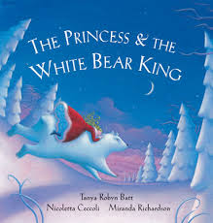 |   Non-chronological report (My School) | 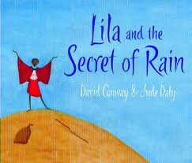
Outcome 1- Diary  (10 days) | Outcome 1- School Prospectus  (10 days) | Outcome 1- Narrative  (10 days)
STAR WORDS  Fairest, dreamy, intricate, shaggy, snow-white pelt, toss, exchange, mutter bury, clamber  GRAMMAR: -LI: To know how to use synonyms  GRAMMAR IN CONTEXT: - LI: To know how to use synonyms in the context of the text | STAR WORDS  English, Maths, Science, IPC, History, Geography, learning, rules, Stoke, Plymouth  GRAMMAR: -LI: To know how to use commas in a list  GRAMMAR IN CONTEXT: - LI: To know how to use commas in a list in the context of the text | STAR WORDS  Foot, crops, weeping, flocks, scorching, ebony, emotion, echoed, awash  GRAMMAR: -LI: To know how to use adjectives  GRAMMAR IN CONTEXT: - LI: To know how to use adjectives in the context of the text
Outcome 2-Persuasive Writing (10 days) | Outcome 2 – N/A | Outcome 2- Non-Chronological Report (10 days)
STAR WORDS  Turrets, lavish, rumbled, lumbered, stirred, delight, drifted, generous, evil enchantment, troll  GRAMMAR: -LI: To know how to use verbs and adverbs  GRAMMAR IN CONTEXT: - LI: To know how to use verbs and adverbs in the context of the text |  | STAR WORDS  Kenya, Masai, Game Parks, Mount Kenya, Nairobi, Continent  GRAMMAR: -LI: To use a range of grammar  GRAMMAR IN CONTEXT: - LI: To use a range of grammar in context
Outcome 3- Narrative (Story Retell)  (10 days) | Outcome 3- N/A | Outcome 3- N/A
STAR WORDS
Spying, cunning, draught, slumber, bedchamber, toil, feast, master, suspicious, flinch, embraced
GRAMMAR: -LI: To know how to use speech bubbles and speech marks
GRAMMAR IN CONTEXT: - LI: To know how to use speech bubbles and speech marks in the context of the text

