YEAR 1- AUTUMN 24-25
Term 1 |  | Term 2
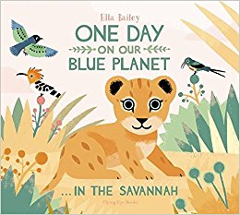 | 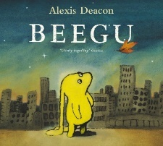 | 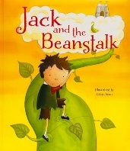 | 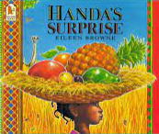
Outcome 1- Annotating Illustrations  (5 days) | Outcome 1- Character Description  (5 days) | Outcome 1- Story Mapping & Retelling (5 days) | Outcome 1- List Writing  (5 days)
STAR WORDS: savannah, cub, lion. Lioness, heat, grassland, Africa, pride, growling, stalking, chasing, prey  GRAMMAR: -LI: To know how to use finger spaces  GRAMMAR IN CONTEXT: - LI: To use finger spaces in my annotations | STAR WORDS: Beegu, lost, alone, Earth, creatures, unfriendly, hopeful, remember  GRAMMAR: LI: To know how to use ‘and’ in a sentence  GRAMMAR IN CONTEXT: - LI: To use ‘and’ to join my ideas | STAR WORDS: Beanstalk, magic beans, giant, cottage, market, poor, flinging, enchanted, castle, twitched, harp, axe,  GRAMMAR: LI: To use adjectives to describe  GRAMMAR IN CONTEXT: - LI: To use adjectives to add to my story map to aid my retelling | STAR WORDS: Basket, Handa, Akeyo, surprised, village, banana, guava, orange, mango, pineapple, avocado, passion-fruit, tangerine, soft, yellow, sweet-smelling, round, juicy, ripe, red, spiky-leaved, creamy, green,  GRAMMAR: LI: To use adjectives to describe e.g. soft yellow banana,  GRAMMAR IN CONTEXT: - LI: To use adjectives to record a list of fruit
Outcome 2- Describing Animals and habitats (5 days) | Outcome 2- Setting Description  (5 days) | Outcome 2- Innovate new story version (10 days) | Outcome 2- Description  (5 days)
STAR WORDS Furry, stripy, spotty, scaly, smooth, strong, agile, swift, heavy, dry, warm, dusty,  GRAMMAR: To use adjectives to describe  GRAMMAR IN CONTEXT: - LI: To use adjectives to describe animals and/or habitats | STAR WORDS: Noisy, busy, lonely, unfriendly, crowded, city, dark, bright  GRAMMAR: -LI: I can use adjectives in a list  GRAMMAR IN CONTEXT: - LI: To use adjectives in a list to describe a setting | STAR WORDS: Beanstalk, magic beans, giant, cottage, market, poor, flinging, enchanted, castle, twitched, harp, axe,  GRAMMAR: LI: to begin to use capital letters and full stops  GRAMMAR IN CONTEXT: - LI: To use capital letters and full stops for each sentence in my story | STAR WORDS: soft, yellow, sweet-smelling, round, juicy, ripe, red, spiky-leaved, creamy, green, tangy, purple,  ALAN PEAT- List Sentences- The soft, yellow banana is sweet inside.  GRAMMAR: LI: to begin to use capital letters and full stops  GRAMMAR IN CONTEXT: - LI: To use capital letters and full stops for each sentence
Outcome 3- Animal Fact File  (5 days) | Outcome 3- Non-Chronological Report ‘Guide to Earth’  (5 days) | Outcome 3- Diary of a Bean growing (5 days) | Outcome 3- N/A
STAR WORDS: Habitat- grassland, Diet: meat, plants, seeds, nuts , Appearance: Furry, stripy, spotty, whiskers, hooves, scaly, smooth, strong, Family- pride, pack, Herd  GRAMMAR: LI: to begin to use capital letters and full stops  GRAMMAR IN CONTEXT: - LI: To use capital letters and full stops for each sentence | STAR WORDS: Earth, humans, play, big, small, friendly, unfriendly, busy  ALAN PEAT- All the W’s- Why visit Earth?  What is there to do?  GRAMMAR: -LI: To know how to use ‘and’ in a sentence (GDS include- ‘because’)  GRAMMAR IN CONTEXT: - LI: To use ‘and’ to join my ideas (GDS include- ‘because’) | STAR WORDS: First, next, then, soil, pot, bean, water, place, cover,  GRAMMAR: LI: To order sentences  GRAMMAR IN CONTEXT: - LI: To write my ideas down in order

YEAR 1 SPRING 24-25
Term 3 |  | Term 4
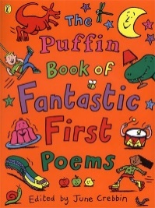 | 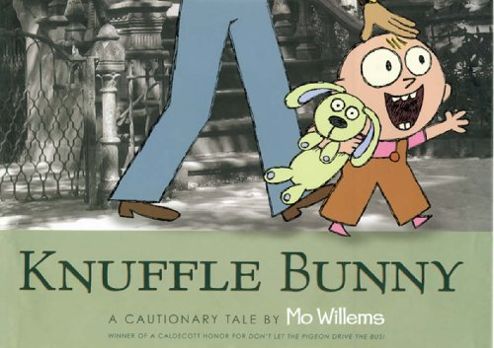 | 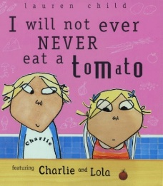 | 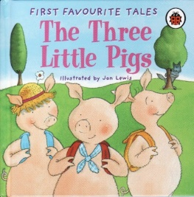
Outcome 1- Free Verse Poem (5 days) | Outcome 1- Recount (5 days) | Outcome 1- Letter Writing (5 days) | Outcome 1- Letter writing in role  (5 days)
STAR WORDS: spaghetti, slimy, slippery, silky, jiggly, sauce, sprinkled, wiggle, slurp, sloshy, squiggle  GRAMMAR: LI: To use adjectives to describe  GRAMMAR IN CONTEXT: - LI: To use adjectives to describe a spaghetti | STAR WORDS: errand, laundromat, boneless, zoomed, lost, found,  GRAMMAR: LI: To order sentences  GRAMMAR IN CONTEXT: - LI: To write my ideas down in order | STAR WORDS: fussy, small, green, spaghetti, mushrooms, Jupiter, mash, Mount Fuji, Greenland, supermarket, tomatoes  GRAMMAR- LI: To use capital letters for names  GRAMMAR: To use capital letters for names in my letter to Lola | STAR WORDS: straw, sticks, bricks, built, blew, squealed, howled, wooden, drainpipe, fireplace, stoked, chimney  GRAMMAR- LI: To use an exclamation mark in a sentence  GRAMMAR: To use an exclamation mark in a sentence to show a strong feeling.
Outcome 2- Description of favourite food (5 days) | Outcome 2- Lost Toy Poster  (5 days) | Outcome 2- Menu Writing (5 days) | Outcome 2- Description of characters (5 days)
STAR WORDS: Delicious, creamy, crunchy, sweet, salty, tangy, sour, soft, slippery, gooey, juicy, saucy,  GRAMMAR: -LI: to use a capital letter for the personal pronoun ‘I’  GRAMMAR IN CONTEXT: - LI: to use a capital Ietter for the personal pronoun ‘I’ | STAR WORDS: errand, laundromat, boneless, zoomed, lost, found, heading, picture, description  GRAMMAR: LI: To use adjectives to describe  GRAMMAR IN CONTEXT: - LI: To use adjectives to describe a missing toy | STAR WORDS: fussy, small, green, spaghetti, mushrooms, Jupiter, mash, Mount Fuji, Greenland, supermarket, tomatoes  ALAN PEAT- List Sentences- The bright, red moonsquirters from Mars.  GRAMMAR: LI: To use a capital letters for places  GRAMMAR IN CONTEXT: - LI: To use a capital letter for a place name | STAR WORDS: straw, sticks, bricks, built, blew, squealed, howled, wooden, drainpipe, fireplace, stoked, chimney  GRAMMAR: -LI: To know how to use ‘and’ in a sentence (GDS include- ‘because’)  GRAMMAR IN CONTEXT: - LI: To use ‘and’ to join my ideas (GDS include- ‘because’)
Outcome 3- Adjective Poem about favourite food (5 days) | Outcome 3- Narrative (Story of a lost toy) (5 days) | Outcome 3- Writing Questions (5 days) | Outcome 3- Innovate new story version (5 days)
STAR WORDS: Delicious, creamy, crunchy, sweet, salty, tangy, sour, soft, slippery, gooey, juicy, saucy,  ALAN PEAT- List Sentences- The juicy, sweet melon, yellow like the sun.  GRAMMAR: LI: To use adjectives to describe  GRAMMAR IN CONTEXT: - LI: To use adjectives to describe my favourite food | STAR WORDS: errand, laundromat, boneless, zoomed, lost, found, heading, picture, description  GRAMMAR: LI: to begin to use capital letters and full stops  GRAMMAR IN CONTEXT: - LI: To use capital letters and full stops for each sentence in my story | STAR WORDS: fussy, small, green, spaghetti, mushrooms, Jupiter, mash, Mount Fuji, Greenland, supermarket, tomatoes  ALAN PEAT- All the W’s- Why, what, where, when how, who. What do you like the eat? Why?  GRAMMAR- LI: To use a question mark when writing questions  GRAMMAR: To use a capital letter at the start and a question mark at the end in my question writing | STAR WORDS: straw, sticks, bricks, built, blew, squealed, howled, wooden, drainpipe, fireplace, stoked, chimney  GRAMMAR: LI: to begin to use capital letters and full stops  GRAMMAR IN CONTEXT: - LI: To use capital letters and full stops for each sentence in my story

YEAR 1- SUMMER 24-25
Term 5 |  | Term 6
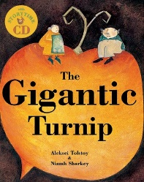 |  | 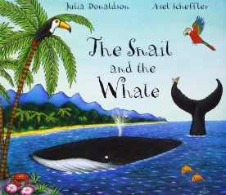 | 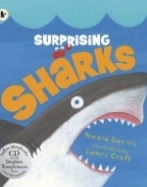
Outcome 1- Sequencing Events  (5 days) | Outcome 4- Instructions (Planting a seed) (5 days) | Outcome 1- Description of feelings  (5 days) | Outcome 1- Labelling a diagram  (5 days)
STAR WORDS: First, next, after that, then, finally, crooked, canary, geese, speckled, pot-bellied, sowed, turnips, harvested, tug, heave, yank, stew,  GRAMMAR: LI: To order sentences  GRAMMAR IN CONTEXT: - LI: To write my ideas down in order | STAR WORDS: First, next, after that, then, finally, soil, pot, seed, water, carefully, gently, shoot, root, stem, leaf  GRAMMAR: LI: To order sentences  GRAMMAR IN CONTEXT: - LI: To write my ideas down in order | STAR WORDS: Humpback whale, snail, slithered, flock, trail, tide, coral, iceberg, frolicked, beached, bay, frightening, small, frail, upsetting, helpless,  GRAMMAR: -LI: To know how to use ‘and’ and ‘because’ in a sentence (GDS include- ‘but, so)  GRAMMAR IN CONTEXT: - LI: To use ‘and’ and ‘because’ to join my ideas (GDS include- ‘but, so) | STAR WORDS: shark, dorsal fin, tail, pelvic fin, pectoral fin, gill slits, skin, eye, jaws, teeth,  GRAMMAR- LI: To use capital letters for names  GRAMMAR: To use capital letters for body part names in my diagram
Outcome 2- Story Mapping & Retelling (10 days) | Outcome 5- N/A | Outcome 2- Description of settings  (5 days) | Outcome 2- Writing notes from research (5 days)
STAR WORDS: First, next, after that, then, finally, crooked, canary, geese, speckled, pot-bellied, sowed, turnips, harvested, tug, heave, yank, stew,  GRAMMAR: LI: To use adjectives to describe  GRAMMAR IN CONTEXT: - LI: To use adjectives to retell the story |  | STAR WORDS: Humpback whale, snail, flock, trail, tide, coral, iceberg, frolicked, beach, bay, fiery mountains, zig zag lightening, golden sands, caves  ALAN PEAT- List Sentences- The bright, golden sand shone in the bay.  GRAMMAR: LI: To use adjectives to describe  GRAMMAR IN CONTEXT: - LI: To use adjectives to describe my favourite food | STAR WORDS: shark, habitat, diet, prey, predator, hunt, plankton, fish, mammals, eggs, young,  GRAMMAR: -LI: To know how to use ‘and’ and ‘because’ in a sentence (GDS include- ‘but, so)  GRAMMAR IN CONTEXT: - LI: To use ‘and’ and ‘because’ to join my ideas (GDS include- ‘but, so)
Outcome 3- Innovate own story  (10 days) | Outcome 6- N/A | Outcome 3- Diary  (10 days) | Outcome 3- Non-Chronological report on Sharks (5 days)
STAR WORDS: First, next, after that, then, finally, crooked, canary, geese, speckled, pot-bellied, sowed, turnips, harvested, tug, heave, yank, stew,  GRAMMAR: LI: to begin to use capital letters, full stops, exclamation marks and question marks.  GRAMMAR IN CONTEXT: - LI: To use capital letters, full stops, exclamation marks and question marks in my story |  | STAR WORDS: Humpback whale, snail, slithered, flock, trail, tide, coral, iceberg, frolicked, beached, bay, fiery mountains, zig zag lightening, golden sands, caves  ALAN PEAT- All the W’s- Why, what, where, when how, who. What will be next? Where will we go?  GRAMMAR: LI: to begin to use capital letters, full stops, exclamation marks and question marks.  GRAMMAR IN CONTEXT: - LI: To use capital letters, full stops, exclamation marks and question marks in my diary | STAR WORDS: shark, habitat, diet, prey, predator, hunt, plankton, fish, mammals, eggs, young,  GRAMMAR: LI: to begin to use capital letters, full stops, exclamation marks and question marks.  GRAMMAR IN CONTEXT: - LI: To use capital letters, full stops, exclamation marks and question marks in my non-chronological report

