EYFS- AUTUMN 24-25
Term 1 |  |  | Term 2
Baseline assessments  Reading for pleasure | 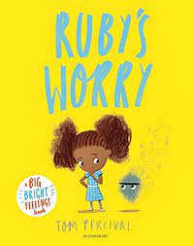 | 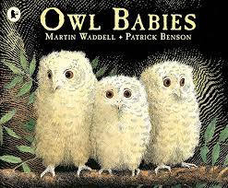 | 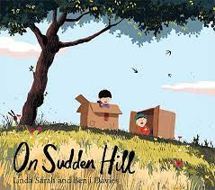 | 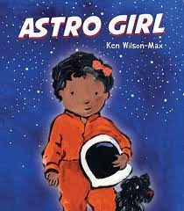 | Nativity
Outcome 1- Sharing stories  (5 days) | Outcome 1- Discussion of the text  (5 days) | Outcome 1- Speech and thought bubbles (5 days) | Outcome 1-  (5 days) Shared Journal | Outcome 1-  (5 days) Lists | Outcome 1- Caption Writing  (5 days)
 | STAR WORDS:  Literacy Objectives:  3&4:  - Engage in extended conversations about stories, learning new vocabulary  -Use some of their print and letter knowledge in their early writing | STAR WORDS:  Literacy Objectives:  3&4:  - Engage in extended conversations about stories, learning new vocabulary  -Use some of their print and letter knowledge in their early writing | STAR WORDS:  Literacy Objectives:  3&4:  - Engage in extended conversations about stories, learning new vocabulary  -Use some of their print and letter knowledge in their early writing | STAR WORDS:  Literacy Objectives:  3&4:  - Engage in extended conversations about stories, learning new vocabulary  -Use some of their print and letter knowledge in their early writing | STAR WORDS:  Literacy Objectives:  3&4:  - Engage in extended conversations about stories, learning new vocabulary  -Use some of their print and letter knowledge in their early writing
Outcome 2- (5 days) | Outcome 2-  (5 days)  Illustrations showing emotions | Outcome 2- (5 days)  Notes to the baby Owls | Outcome 2-  (5 days)  Speech and thought bubbles | Outcome 2-  (5 days) Personal Narrative | Outcome 2- Performance  (5 days)
The writing curriculum for EYFS is planned out to provide children with a range of exciting writing opportunities based around quality texts. The writing outcomes may be adapted to suit the needs and interests of the children throughout the year.

EYFS- SPRING 24-25
Term 3 |  |  | Term 4
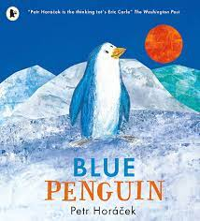 | 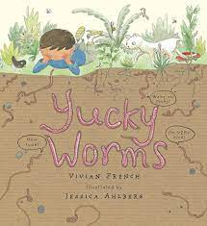 | 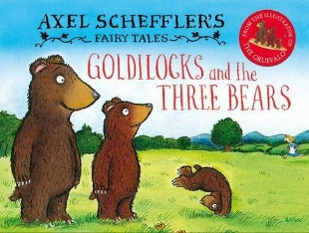 | 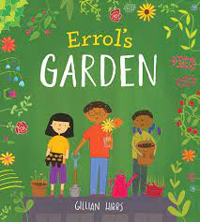 | 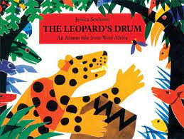 | Easter Story
Outcome 1-  (5 days)  Speech and thought bubbles | Outcome 1- Caption writing  (5 days) | Outcome 1- Retelling (5 days) | Outcome 1- Labelling  (5 days) | Outcome 1- Thought Bubbles  (5 days) | Outcome 1-  (5 days) Sequencing
Star Words:  Literacy Objectives:  3&4:  - Use some of their print and letter knowledge in their early writing  - Write some or all of their name.  - Write some letters accurately. | Star Words:  Literacy Objectives:  3&4:  - Use some of their print and letter knowledge in their early writing  - Write some or all of their name.  - Write some letters accurately. | Star Words:  Literacy Objectives:  3&4:  - Use some of their print and letter knowledge in their early writing  - Write some or all of their name.  - Write some letters accurately. | STAR WORDS: First, next, then, soil, pot, bean, water, place, cover,  Literacy Objectives:  3&4:  - Use some of their print and letter knowledge in their early writing  - Write some or all of their name.  - Write some letters accurately.  Reception:  - Form lower-case and capital letters correctly.  - Spell words by identifying the sounds and then writing the sound with letters | Star Words:  Literacy Objectives:  3&4:  - Use some of their print and letter knowledge in their early writing  - Write some or all of their name.  - Write some letters accurately.  Reception:  - Form lower-case and capital letters correctly.  - Spell words by identifying the sounds and then writing the sound with letters | Star Words:  Literacy Objectives:  Reception:  - Form lower-case and capital letters correctly.  - Spell words by identifying the sounds and then writing the sound with letter/s.  - Write short sentences with words with known letter-sound correspondences using a capital letter and full stop
Outcome 2- (5 days)  Caption Writing | Outcome 2- Information Writing  (5 days) | Outcome 2- Retelling  (5 days) | Outcome 2- Plant care instructions  (5 days) | Outcome 2-  (5 days)  Story map | Outcome 2-  (5 days)  Responses to illustrations

EYFS- SUMMER 24-25
Term 5 |  |  | Term 6
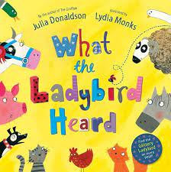 | 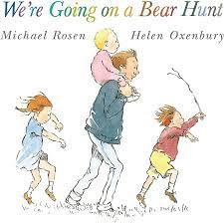 | 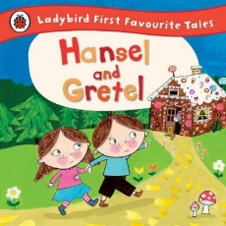 | 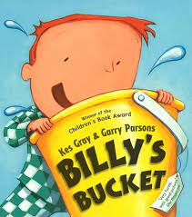 | 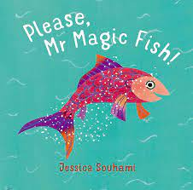 | 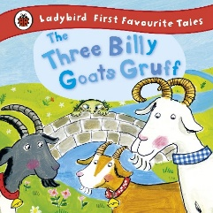
Outcome 1- Speech/Thought bubbles  (5 days) | Outcome 1- Sign writing  (5 days) | Outcome 1- (5 days)  Story mapping | Outcome 1-  (5 days) | Outcome 1-  (5 days)  Wishes, hopes and dreams | Outcome 1-  (5 days)  Sequencing
STAR WORDS: First, next, then, soil, pot, bean, water, place, cover,  Reception:  - Form lower-case and capital letters correctly.  - Spell words by identifying the sounds and then writing the sound with letter/s.  - Write short sentences with words with known letter-sound correspondences using a capital letter and full stop | Star Words:  Literacy Objectives:  ELG:  - Write recognisable letters, most of which are correctly formed.  - Spell words by identifying sounds in them and representing the sounds with a letter or letters.  - Write simple phrases and sentences that can be read by others. | Star Words:  Literacy Objectives:  ELG:  - Write recognisable letters, most of which are correctly formed.  - Spell words by identifying sounds in them and representing the sounds with a letter or letters.  - Write simple phrases and sentences that can be read by others. | Star Words:  Literacy Objectives:  ELG:  - Write recognisable letters, most of which are correctly formed.  - Spell words by identifying sounds in them and representing the sounds with a letter or letters.  - Write simple phrases and sentences that can be read by others. | Star Words:  Literacy Objectives:  ELG:  - Write recognisable letters, most of which are correctly formed.  - Spell words by identifying sounds in them and representing the sounds with a letter or letters.  - Write simple phrases and sentences that can be read by others. | Star Words:  Literacy Objectives:  ELG:  - Write recognisable letters, most of which are correctly formed.  - Spell words by identifying sounds in them and representing the sounds with a letter or letters.  - Write simple phrases and sentences that can be read by others.
Outcome 2- (5 days)  Map making | Outcome 2-  (5 days) Messages to the characters | Outcome 2- (5 days)  Writing in role | Outcome 2-  (5 days) | Outcome 2-  (5 days) Plans for acts of kindness | Outcome 2-  (5 days)  Retell

